## NAME:S.Logitha

## REG NO:192121138

**16.USING RAPTOR – AMSTRONG NUMBER OR NOT**

**FLOWCHART**

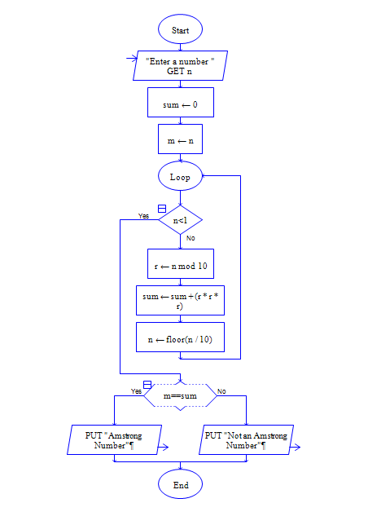

**INPUT**

371

**OUTPUT**

